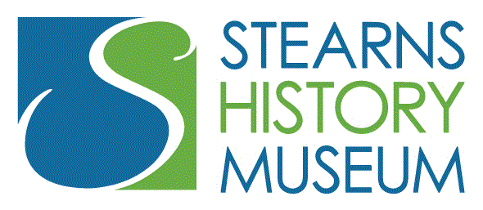
Stearns History Museum
JOB TITLE Collections Assistant/Registrar
Job Type: Part Time/20 hours per week
Reports to: Collections Curator
Compensation: $15-$18/hour DOQ
Contact: Eric Cheever, Curator,
echeever@stearns-museum.org
320-253-8424

Please submit cover letter and resume by email by November 25, 2020.

About the Stearns History Museum
The Stearns County Historical Society (d.b.a.) Stearns History Museum is a place to learn, discover and discuss history. The Museum connects people through the power of history and culture. We serve our community through public programs, publications and professional associations. We are stewards of stories and protectors of artifacts and archives. We strive to engage everyone. All are welcome
Stearns History Museum serves the public online and in person. We operate year round. The Stearns History Museum is the anchor of the City of St. Cloud’s Heritage Park, an 80-acre nature park with walking trails, abundant wildlife, and a skateboard park. There truly is something for everyone.

PRIMARY RESPONSIBILITIES:
Employee will be expected to care for the Stearns History Museum's 34000 artifact collection. Duties include:
- accurately identify, research and catalog new three dimensional artifacts as they are acquired and accepted by the museum,
- Box/shelf artifacts in appropriate containers in the collection storage facility.
- care and maintenance of existing three dimensional collections
- assist the Curator in exhibit production/construction.
DETAILED RESPONSIBILITIES:
Accession newly acquired artifacts. Includes researching, identifying, describing and photographing object before entering information into collections digital catalog.
Assess and procure best storage option for accessioned artifact, boxing and shelving object and recording storage location into collections catalog.
Assisting with maintenance of existing three dimensional collections for condition and cleanliness.
Assist curator in exhibit production, research and construction as needed.

Other Duties as Assigned

QUALIFICATIONS:
- Must embrace, support, honor, and advance the mission and public history of the Stearns History Museum.
- Must have strong computer skills including use of MS Office suite and database management.
- Must have a working knowledge of the history and identification of artifacts/America’s physical and industrial past.
- Associates or Bachelor’s Degree with experience in history, museum studies, or library sciences or related field.
- Excellent writing, project management and interpersonal skills
- Must have valid driver license.
- Must pass a background check.
- Must be willing and able to work Saturdays. Museum office hours are Tuesday through Saturday 9 am to 5 pm.
- Must be willing and able to work as a member of a team
- Must be able to independently prioritize work and work independently
- Knowledge of organizing and cataloging objects in a collection;
- knowledgeable about conservation methods, materials, and resources for objects;
- Supervise and work successfully with volunteers

Physical Demands: While performing the duties of the job, the employee is regularly required to stand/walk as well as lift/move large heavy objects weighing up to fifty pounds.

